
Arizona Department
of Health Services
Bureau of Emergency Medical Services and Trauma System

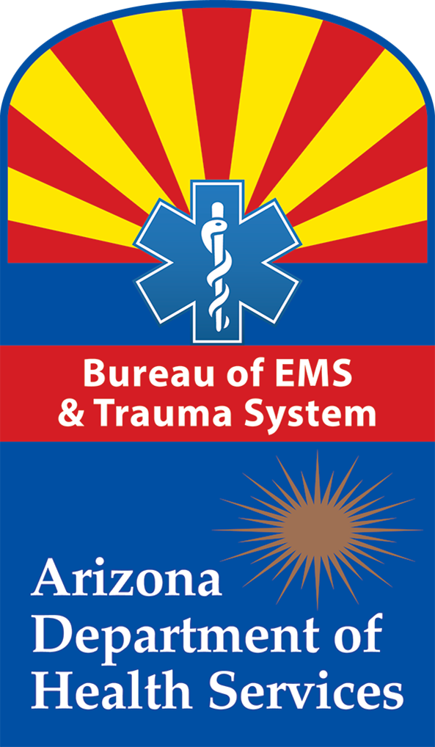
Premier EMS Agency Program
(PEAP)
Application and Handbook

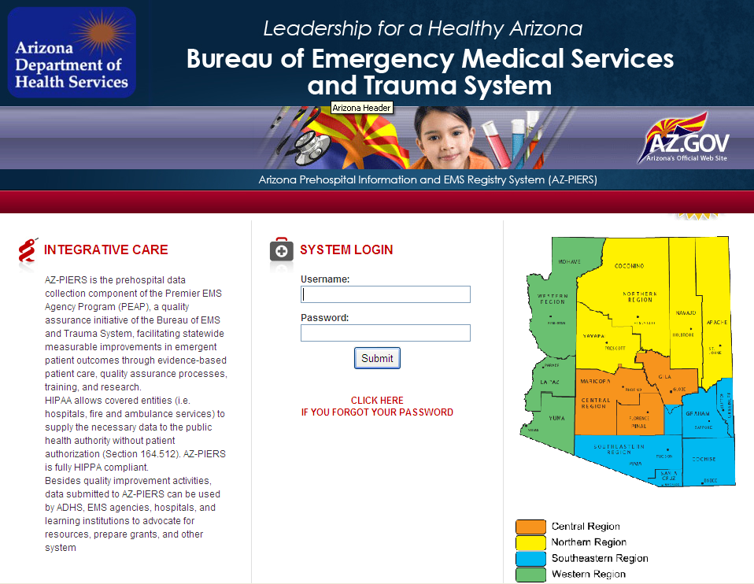
What is the Premier EMS Agency Program (PEAP)?

PEAP is a quality assurance initiative through the Arizona Department of Health Services (ADHS) in the Bureau of Emergency Medical Services and Trauma System (BEMSTS). The PEAP recognizes Arizona’s EMS agencies for their dedication to improve the care they provide for their patients. All PEAP agencies have demonstrated to ADHS that they have:

- A senior director that attests the agency is committed to use data to optimize patient care through the establishment of policies, personnel, and resources,
- A committed and empowered quality assurance team that reviews 100% of runs dealing with:

- Major Trauma,
- Acute Stroke,
- ST segment Elevation Myocardial Infarction (STEMI),
- Out of Hospital Cardiac Arrest (OHCA).
- An electronic Patient Care Reporting (ePCR) system that submits all runs to the Arizona Prehospital Information and EMS Registry System (AZ-PIERS) consistent with data submission guidelines,
- Active attendance and participation in applicable Data and Quality Assurance (DQA) initiatives,
- A process or system that uses data from the ePCR system to develop training, education, and policies that enhance patient care.

Agencies that attain at least three of the requirements will be recognized as a Participating Agency.
Agencies that implement all five parts of the program will be recognized as a Premier EMS Agency.

How will the BEMSTS help our agency?

BEMSTS staff will:

- Provide you with resources that can be personalized to your agency,
- Determine baseline and benchmarking through the analysis of aggregate data in the system,
- Develop opportunities and initiatives for stakeholders to implement best practices and policies.

The true beneficiaries of PEAP are the citizens of Arizona. As a provider you can feel proud that your agency is dedicated to evidenced-based processes. This initiative intends to optimize the EMS trauma system, your agency, and the outcomes of patients.

Is my data safe?

In one word, yes! All data is protected from subpoena and discoverability. PEAP is the ADHS quality assurance initiative dedicated to improving care for EMS patients in Arizona. Any data that is related to the actions and processes of the quality assurance process shall be confidential. Additionally, any individual or health care entity involved in the quality assurance process cannot be subpoenaed solely on activities related to the quality assurance. Policies prevent the release of information that could identify (1) the patient, (2) the patient’s family, (3) the health care provider (the EMT), or (4) the Agency.

All ePCR data must be exported electronically to the Arizona StateBridge website at https://azemsis.azdhs.gov. It is the responsibility of the agency contact to maintain their secure username and password issued by the BEMSTS, determine access to their agency’s data, and create users that have access to their reports and data.

Regulatory Feedback: The Premier EMS Agency Program is a QUALITY ASSURANCE INITIATIVE of BEMSTS that is administered by the DQA. BEMSTS is statutorily PROHIBITED from using quality improvement data for ANY regulatory related activities.

Freedom of Information Act: The Department of Health Services and BEMSTS are required to release de-identified aggregate data to the public. Any information released cannot contain any identifiable information related to the patient, the patient’s family, the health care provider, or the agency.

Research: The EMS database must be made available for appropriate research activities to be consistent with ADHS policy. Oversight guidelines require that safeguards on data reporting, storage, and destruction are in place to protect the patient, the patient’s family, health care provider, and agency. All research requests are reviewed by the ADHS Human Subject Review Board to ensure the implementation of these safeguards.

Unauthorized Access: All public health data collected by the Department of Health are protected from external, unauthorized access. The IT firewall system is comprehensive and is constantly monitored. All individuals accessing public health data are required to sign and follow data protection agreements.

How will my data be used?

Reports for contributing agencies: The DQA staff will provide each contributing agency with reports of their system level performance measures for the four diseases (STEMI, OHCA, trauma, stroke). Additionally, aggregate data will be used to benchmark for other reporting agencies.

Reports for counties, regional, statutory and standing committees: DQA staff will develop de-identified reports on EMS issues in Arizona. Other typical registry reports will include information on the nature and frequency of EMS use in the State of Arizona.

System and Outcome Analysis: BEMSTS will be able to analyze our state’s effectiveness for system and clinical perspective.

NEMSIS (optional but strongly recommended): The National EMS Information System (NEMSIS) was established to help states develop standardized elements. This database will be used to provide insight into EMS on a local, state, and national level. NEMSIS protects your data to the same extent as the state and is protected against subpoena and discoverability. Arizona’s participation will help develop nationwide EMS training material, outcomes for patients, research, and resources.

Please visit http://www.nemsis.org/index.html for more information.

To get started fill out the attached forms and return them to BEMSTS by email to Rogelio.Martinez@azdhs.gov.
DQA will then contact you to begin the process.

- Senior Management Affirmation Form
- Application Form

All information received in connection with the Quality Assurance Process is confidential including this application
Data Submission Requirements:

As of December 1, 2014 the following policy will be implemented.

Compliance Standard for Data Submission

Data submission is an essential component of the Premier status. Per the EMS Registry User’s Group (EMSRUG) guidelines, records must be submitted monthly to AZ-PIERS. EMS agencies can submit records on a more frequent and regular basis.

Month | Patient Treatment Dates | Data Due Date
January | January 1- 31 | February 28 of same year
February | February 1 – 28/29 | March 31 of same year
March | March 1 - 31 | April 30 of same year
April | April 1 - 30 | May 31 of same year
May | May 1 - 31 | June 30 of same year
June | June 1 - 30 | July 31 of same year
July | July 1 - 31 | August 31 of same year
August | August 1 - 31 | September 30 of same year
September | September 1 - 30 | October 31 of same year
October | October 1 - 31 | November 30 of same year
November | November 1 - 30 | December 31 of same year
December | December 1 - 31 | January 31 of next year

Compliance Standard for Data Quality

The EMS Registry User’s Group (EMSRUG) will annually review and modify a data quality report given to agencies. Acceptable levels of data completeness, null values, and validation scores will be established by EMSRUG and TEPI workgroups in 2015 for premier level agencies.

Revocation of PEAP status

Premier EMS Agency status revocation will occur when an agency cannot meet the standards for data submission or data quality.

An agency that is unable to come into compliance with the data submission standards over any 60 consecutive days or 90 days over a 12-month period will receive a written warning.

An agency that is unable to come into compliance with the data quality standards for two consecutive reports or for any three reports over the EMSRUG established timeframe will receive a written warning.

Agencies have 30 days from the date on the written warning to come into compliance with the data submission or data quality standards. Agencies that are unable to do so will be automatically downgraded to participating status and removed from the website as a Premier Level agency.

If an agency contacts Rogelio.Martinez@azdhs.gov by email to explain the extenuating circumstances they may receive an additional maximum grace period of 30 days.

An agency whose Premier EMS Agency status has been revoked may not re-apply for a 6 month period that begins on the date of revocation. Data submission must be backlogged and meet data quality standards for all missing cases prior to reinstatement of premier status.

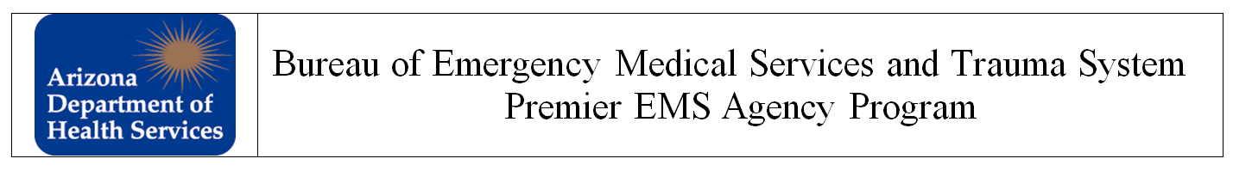

Please provide all requested information using black or blue ink only. You may type or handwrite your responses
Section A. Agency Information
1 | Agency Name
2 | Business Address
3 | Phone Number
4 | E-Mail Address

Section B. Agency Service
1 | Service Level | BLS ALS BOTH
2 | Number of EMS Runs/Yr | BLS: Transp. , Non-Transp. , ALS: Transp. , Non-Transp.

Section C. Agency Administration
1 | Chief Administrator Name
2 | Phone Number
3 | E-Mail Address

1 | Admin. Medical Director Name(If Applicable)
2 | Phone Number
3 | E-Mail Address

1 | Base Hosp. Coordinator Name(If Applicable)
2 | Phone Number
3 | E-Mail Address

1 | QA Manager Name
2 | Phone Number
3 | E-Mail Address

Section D. EMS Data Collection and Submission Agency
1 | Do you use electronic patient care reports (ePCRs)? | YES (continue to 2,3) NO (continue to 4)
2 | If YES, Who is your software vendor?
3 | If YES, What is the product name & version?
4 | If NO, When you will start using electronic patient care reports? |  | N/A
5 | Will your agency send EMS Run Data to the Bureau of EMS & Trauma System? |  |  | YES NO

Section E. EMS Quality Assurance
1 | Does your EMS agency currently have a Quality Assurance Program? | YES NO
2 | If Yes to E.1, please attach copies of your agency’s QA process, and copies of approved policies that encompass 100% review of the four clinical areas: ST-elevation MI, Major Trauma, Stroke, and Out-of-Hospital Cardiac Arrest.
3 | Would you like assistance from the BEMSTS in establishing a QA process? | YES NO

Section F. Senior Management Affirmation
I, the undersigned, as the Senior Manager for the named Agency listed in Section A.1 above herein this application agree to promote the quality assurance process within my agency. I will ensure that there exists a Quality Assurance Committee that meets at least quarterly and that I or my designee will attend. I further agree to ensure that written policies and procedures are produced, put in place, and followed that document the quality assurance process and include the four clinical areas: ST-elevation MI, Major Trauma, Stroke, and Out-of-Hospital Cardiac Arrest. If my agency utilizes an Administrative Medical Director responsible for the care provided by my agency, I will seek his/her participation in the quality assurance process. I will further ensure continued efforts toward achieving the four components necessary to be recognized as a Participant Agency in the BEMSTS Premier EMS Agency Program. I understand that the Premier EMS Agency Program is voluntary and non-punitive. I agree with the established mission of the program, which is to promote evidence-based treatments and integrated quality assurance process of the Arizona EMS and Trauma System to provide the best care for the citizens and visitors of Arizona.
Senior Manager Signature
Printed Name: |  |  | Date:
Thank you for applying to participating in the Premier EMS Agency Program. You will be contacted by a BEMSTS staff member via email within two weeks of the BEMSTS receiving your completed and signed application and signed Data User Affirmation Agreement to provide your ADHS-assigned Username and Password and the Health Services Gateway Manual for PEAP Participants.
Description of QA Process (Required)

