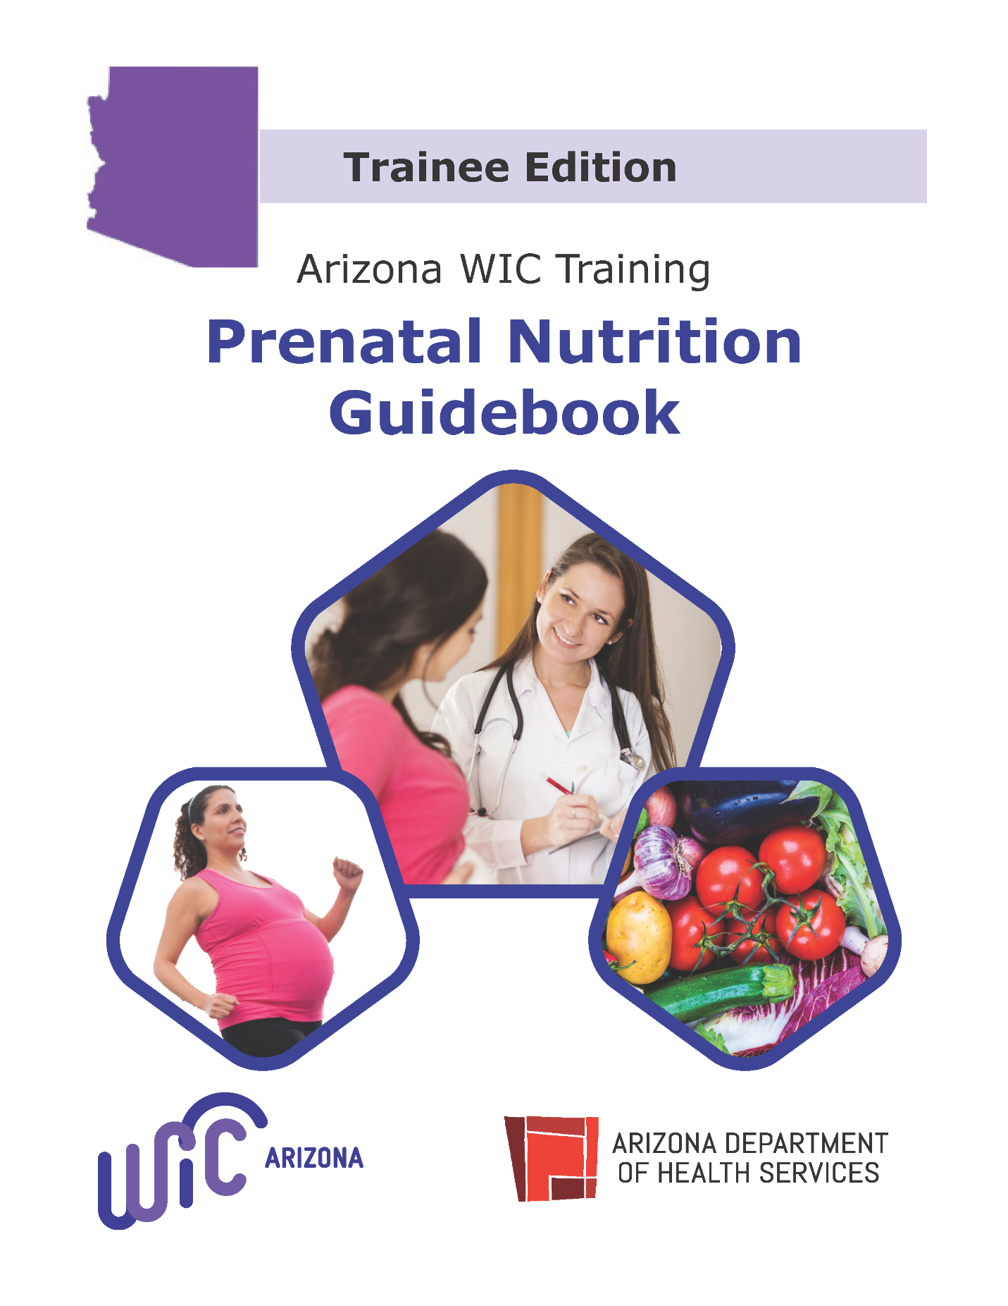

Training Notes

Module 1 Notes

What are some examples of safe physical activities vs activities to avoid during pregnancy?

Safe Activities | Avoid Activities

Module 2 Notes

Recommended Daily Intake of Folic Acid
Pre-Pregnancy
During Pregnancy

Food sources of folate:

Food sources of folic acid (fortified):

Recommended Daily Intake of Iron
Pre-Pregnancy
Pregnancy

Food sources of iron:

Food sources of vitamin C:

Module 3 Notes

Recommended Weight Gain During Pregnancy

Pre-Pregnancy | Single | Twins | Triplets | Quadruplets or more
Underweight |  | —----
Normal Weight
Overweight
Obese

Typical amount of weight gained in the first trimester: ___________.

Approximate number of additional calories needed in the second and third trimester: ______________ per day.

Foods to avoid during pregnancy:

Seafood recommendations during pregnancy:
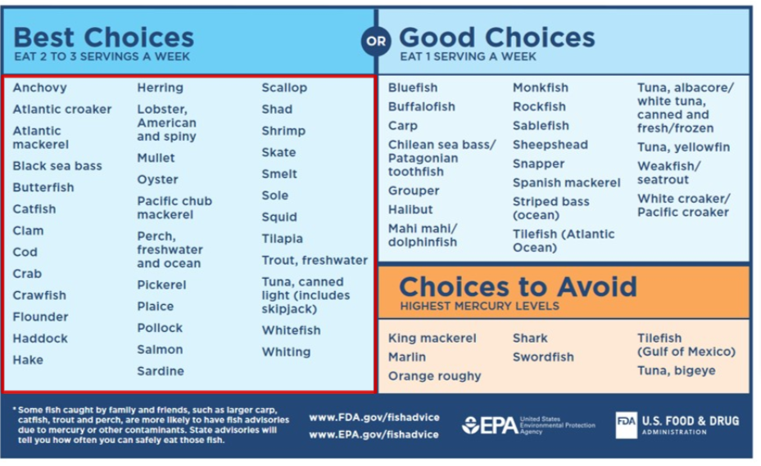

Module 4 Notes

Maximum Caffeine Intake Per Day During Pregnancy

Beverage | Ounces equivalent to Max (8oz = 1 Cup)
Coffee
Tea
Soda

Referral for | Organization | Phone Number | Website
Smoking
Illegal Drugs

Module 5 Notes

Pregnancy Discomfort | Tips for Possible Relief
Nausea and Vomiting
Constipation
Edema (Swelling)

Module 6 Notes

Potential Concern | Signs to listen for
High Blood Pressure
Toxoplasmosis
Lead Exposure
PICA
Depression

Practice Activities

- A pregnant WIC participant tells you that she wasn’t physically active before pregnancy, and isn’t planning to start participating in physical activities because she heard that it isn’t safe to start exercising during pregnancy. She asks for your opinion. How would you respond?

- A pregnant WIC participant tells you that she heard that there are some foods that she’s not supposed to eat during her pregnancy so that she doesn’t get listeriosis and asks you for your recommendation. How would you respond?

- A WIC participant in the 10th week of her pregnancy tells you that she’s been having some nausea lately, but it gets especially bad when her family is cooking chorizo and menudo. She tells you that she has stopped eating those foods, and will even leave the house to avoid the smell. She asks you how long you think her nausea will last and when she’ll be able to resume eating those foods. How would you respond?

- A pregnant WIC participant tells you that she’s been having some edema (swelling due to fluid) during her pregnancy. She asks if you have any recommendations. How would you respond?

Live Training Notes

Prenatal Post Test 3.2024

Read each of the questions below, then click the box next to the correct answer.

- Women who receive prenatal care are more likely to:
☐ | have healthy babies.
☐ | have fewer complications during labor and recovery.
☐ | have less complications during labor and recovery.
☐ | All of the above

- Which is current information about physical activity and pregnancy?
☐ | Women should check with their healthcare providers about amounts and types of physical activities
☐ | Most women can participate in physical activities, even if they weren’t physically active before pregnancy.
☐ | Walking, dancing and strength training are considered safe activities during pregnancy
☐ | All of the above

3. What is the recommendation about dental care for pregnant women?
☐ | During pregnancy women are less likely to develop gum disease.
☐ | Brush and floss daily, with professional dental cleanings at least every 6 months.
☐ | Women can expect to lose one tooth during each pregnancy.
☐ | Going to the dentist is considered dangerous during pregnancy.

4. True or False? The weight gain of pregnancy should be as little as possible, so the baby will be small and easier to deliver.
☐ | True
☐ | False

5. A pregnant woman has gained only three pounds in the first 10 weeks of her pregnancy.
☐ | This does not fit the normal range of 1 pound/week weight gain.
☐ | This is within the normal range of 2-5 pounds in the first trimester.
☐ | One needs to know her weight status before she was pregnant to know if this is normal.
☐ | No weight gain is expected in the first trimester.

6. Energy needs for most healthy women in the second and third trimesters of pregnancy increase by about:
☐ | 150 - 250 calories/day.
☐ | 250 – 350 calories/day.
☐ | 350 – 450 calories/day.
☐ | 450 – 550 calories/day.

7. True or False? It is recommended that women with normal weight before pregnancy gain 25-35 lbs. gain.
☐ | True
☐ | False

8. True or False? There is no known safe level of alcohol for a pregnant woman, so the recommendation is to avoid all alcohol during pregnancy
☐ | True
☐ | False

9. A pregnant woman mentions that there are several cats in her home. Which of the following could be a potential problem related to caring for the cats?
☐ | Mercury poisoning
☐ | Toxoplasmosis
☐ | Lead poisoning
☐ | Listeriosis

10. A pregnant woman enjoys the imported, brightly colored ceramic dishes in her old home. To avoid ___________________, she should know more about what causes the condition, including exposure to some ceramics and old paint.
☐ | Mercury poisoning
☐ | Toxoplasmosis
☐ | Lead poisoning
☐ | Listeriosis

11. True or False? Herbal supplements and natural home remedies sold without prescriptions can be used during pregnancy, even without checking with one’s doctor first.
☐ | True
☐ | False

12. Uncooked meats, such as hot dogs, and unpasteurized soft cheeses can result in _____________, a type of foodborne illness which is easily passed to unborn babies.
☐ | Tuberculosis
☐ | Toxemia
☐ | Gestational diabetes
☐ | Listeriosis

13. Which of the following are NOT conditions commonly associated with pregnancy?
☐ | Nausea and vomiting
☐ | Constipation
☐ | Eye, ear and throat infections
☐ | Swollen legs

14. True or False? High blood pressure is related to preeclampsia, a condition that requires medical attention.
☐ | True
☐ | False

15. A baby is at greater risk of prematurity and low birth weight, if:
☐ | The mother experienced food cravings during pregnancy.
☐ | The baby is the first baby.
☐ | The mother is a teenager.
☐ | The mother continues her physical activity throughout the pregnancy.

16. A pregnant woman who craves and eats non-foods, such a dirt, ashes, large quantities of ice, paint chips or baking soda is experiencing _______________, a condition of unknown cause which can contribute to poor absorption of nutrients and other health problems.
☐ | anorexia
☐ | bulimia
☐ | pica
☐ | pellagra

17. Which of the following especially needs adequate nutrients during pregnancy
☐ | A healthy 25-year-old mother expecting her first child
☐ | A healthy 20-year-old mother expecting her first child.
☐ | A healthy 35-year-old mother expecting her second child
☐ | A healthy 15-year-old mother expecting her first child.

18. True or False? A woman who is depressed during her pregnancy should be referred to a specialist.
☐ | True
☐ | False

19. When a WIC staff member is told by a WIC participant that she has been, or is currently a victim of domestic violence, an appropriate response is:
☐ | Encourage women to call 911 in emergency situations and offer information for the national domestic violence hotline 1-800-799-SAFE, and the website, www.thehotline.org “
☐ | Ignore her response as you do not want to get involved.
☐ | Ask, “Why don’t you just leave?”
☐ | Say, “You should know better.”

